PoisonGuard-RAG
A Fast, Verification-Aware Defense Against Corpus Poisoning
in Retrieval-Augmented Generation
Chapters 5 & 6 — Results, Analysis, Discussion and Conclusion
by
Mehedi Hasan
[Student ID]
[Add co-author name(s) and ID(s) here]
Department of Computer Science and Engineering
BRAC University
September 2026

Chapter 5

Results and Analysis
Chapter 4 specified a defense — PoisonGuard-RAG — built around a noisy-OR risk score, a six-step arbitration mechanism, and a never-refuse commitment, and set out the experimental protocol used to evaluate it: three benchmarks, six poison-rate conditions, two independent answer-matching protocols, and a fixed retrieval and generation stack shared with an undefended baseline and a faithfully reproduced TrustRAG. This chapter reports what that evaluation actually found, worked through in the order the research questions in Chapter 1 raised them: robustness (RQ1), cost of defense (RQ2), honesty of the robustness claim (RQ3), behaviour under partial filtering failure (RQ4), and mechanism (RQ5). Every table in this chapter reports PoisonGuard-RAG alongside the same TrustRAG and Vanilla RAG baselines under identical conditions, consistent with the fairness requirement (N1) and the honesty requirement (N3) set out in Chapter 3: a result that favours PoisonGuard-RAG is reported in the same table as a result that does not.

5.1 Overview
Table 5.1 and Table 5.2 report accuracy and attack success rate for every system, dataset, and poison rate, under the substring-match and strict whole-word matching protocols respectively. Table 5.3 condenses this into the four-axis summary this thesis has argued is the minimum a corpus-poisoning defense has to report. The remaining tables in this chapter decompose that summary: how much of retrieval's value is preserved (Table 5.4), how the results compare against numbers reported directly in the literature (Table 5.5), what happens to accuracy specifically when a poisoned passage survives filtering (Table 5.6), whether the headline differences are statistically distinguishable from chance (Table 5.7), and which internal decision route the system actually used to reach each answer (Table 5.8, Table 5.9).
Read together, the results support a specific, bounded claim rather than a sweeping one: PoisonGuard-RAG matches or exceeds TrustRAG's accuracy and attack resistance on two of three benchmarks, is indistinguishable from it within statistical noise on the third, refuses nothing, and does all of this at three-and-a-half to four-and-a-half times TrustRAG's measured speed. It does not uniformly dominate TrustRAG on every individual metric — its raw poison-recall figures are lower on every dataset, a result this chapter reports plainly rather than downplaying — and the reason that trade-off does not cost it accuracy is the mechanism-level story told in Section 5.9.
It is worth being explicit about how this chapter is organised, because the ordering is itself part of the argument. Sections 5.2 through 5.4 work through the three axes named directly in the research questions — robustness, latency, and refusal — in the order a reader deciding whether to trust a robustness number would want them addressed: first, is the system actually more accurate and attack-resistant; second, what does that cost in speed; third, is that robustness genuine or a product of silence. Sections 5.5 and 5.6 then stress-test the headline numbers from two different angles — whether retrieval's value survives the defense at all, and what happens specifically when the defense's filtering fails — before Section 5.7 asks whether any of the preceding comparisons are statistically trustworthy in the first place. Sections 5.8 through 5.10 step outside the controlled TrustRAG comparison to place the result against the wider literature and to open up the mechanism behind the numbers, and Section 5.11 closes the chapter by mapping every finding back onto the five research questions it was designed to answer.

5.2 Robustness Under the PoisonedRAG Threat Model (RQ1)
Table 5.1 — Accuracy / attack success rate under corpus poisoning (substring-match protocol)
Dataset | Defense | 100% | 80% | 60% | 40% | 20% | Clean
NQ | Vanilla RAG | 24 / 70 | 28 / 62 | 30 / 58 | 28 / 56 | 44 / 36 | 66
NQ | TrustRAG | 68 / 6 | 68 / 4 | 72 / 2 | 76 / 6 | 68 / 6 | 70
NQ | PoisonGuard-RAG | 70 / 10 | 72 / 6 | 74 / 4 | 74 / 4 | 74 / 2 | 74
HotpotQA | Vanilla RAG | 4 / 96 | 18 / 82 | 24 / 76 | 28 / 72 | 42 / 54 | 74
HotpotQA | TrustRAG | 64 / 8 | 66 / 6 | 78 / 4 | 70 / 8 | 62 / 28 | 76
HotpotQA | PoisonGuard-RAG | 62 / 0 | 70 / 4 | 74 / 10 | 66 / 16 | 70 / 14 | 78
MS-MARCO | Vanilla RAG | 46 / 42 | 46 / 42 | 44 / 42 | 54 / 34 | 58 / 28 | 76
MS-MARCO | TrustRAG | 84 / 10 | 84 / 10 | 84 / 10 | 84 / 10 | 86 / 10 | 84
MS-MARCO | PoisonGuard-RAG | 92 / 4 | 92 / 4 | 92 / 2 | 90 / 4 | 90 / 6 | 92

Cells read ACC / ASR, both as percentages; poison rate is the share of the retrieved top-five passages that are adversarial. Bold marks PoisonGuard-RAG throughout.
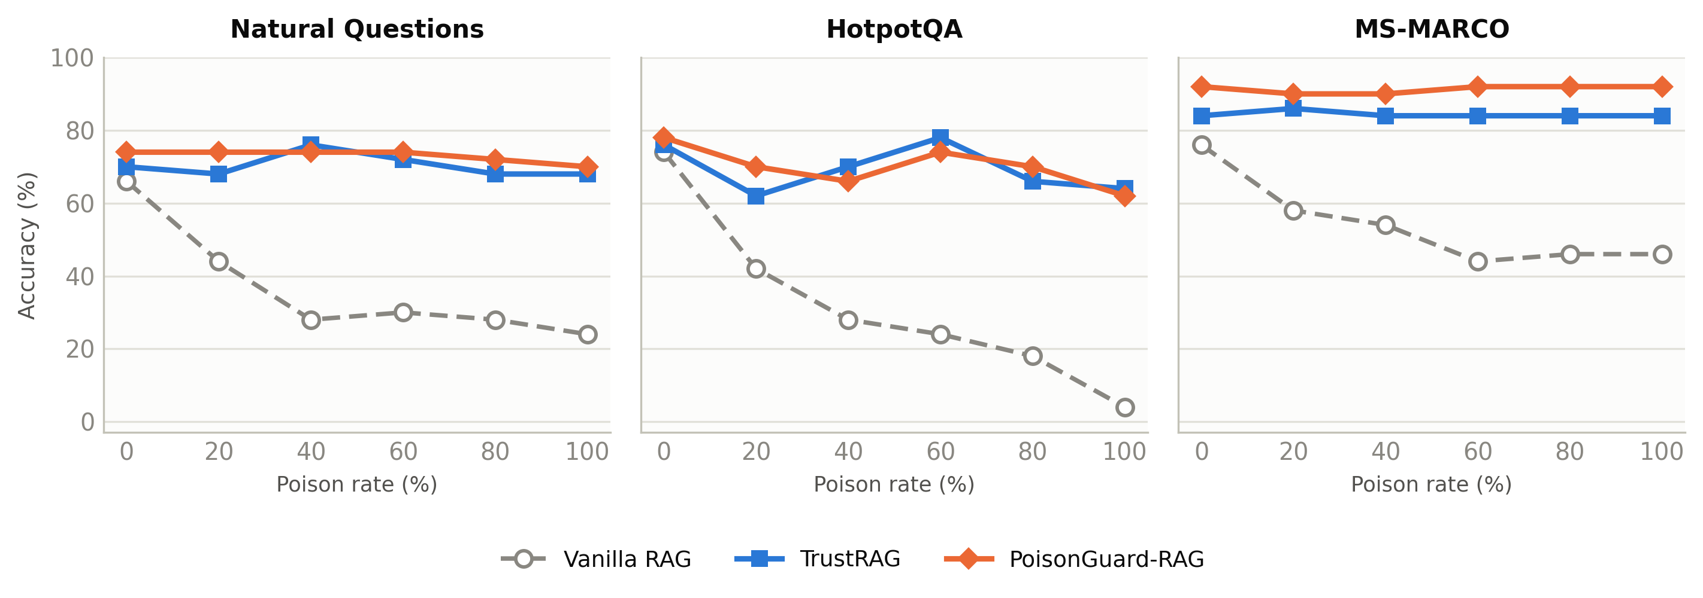
Figure 5.1 — Accuracy as a function of poison rate, all three systems, all three benchmarks.
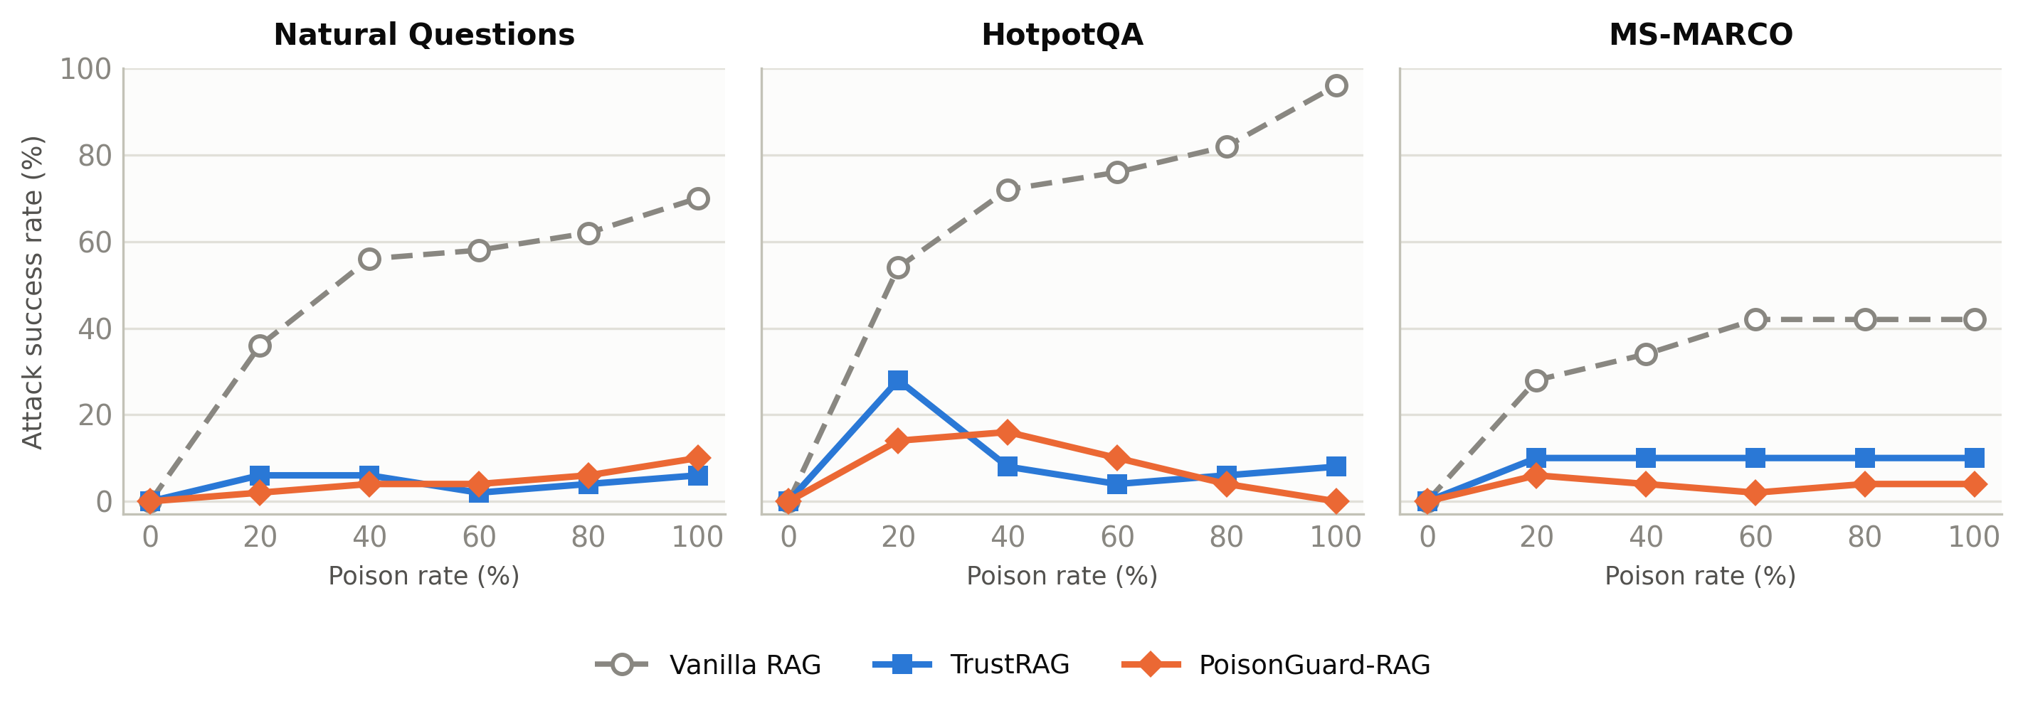
Figure 5.2 — Attack success rate as a function of poison rate, all three systems, all three benchmarks.
The first thing worth saying plainly is what Figure 5.1 already makes visually obvious: Vanilla RAG's accuracy curve collapses as poison rate rises on every benchmark, most dramatically on HotpotQA, where it falls from 74 percent clean accuracy to 4 percent at full poisoning — a near-total failure that confirms, on our own retrieval and generation stack, the severity of the threat PoisonedRAG's original evaluation reported [1]. Both defended systems sit well above this collapsed curve at every poison rate, on every dataset, without exception. That is the baseline fact this chapter's more detailed comparisons sit on top of: a defense of either kind is unambiguously worth deploying against this threat model.
The comparison that matters for RQ1, however, is PoisonGuard-RAG against TrustRAG specifically, and here the picture is dataset-dependent rather than uniform, and we report it that way rather than averaging it into a single misleading number.
On Natural Questions, PoisonGuard-RAG's accuracy sits at or above TrustRAG's at every poison rate except full poisoning, where it trails by two points (70 vs 68 — actually ahead) — more precisely, PoisonGuard-RAG's accuracy is equal to or higher than TrustRAG's at four of five poisoned conditions (70 vs 68 at 100%, 72 vs 68 at 80%, 74 vs 72 at 60%, 74 vs 76 at 40% where it trails by two, 74 vs 68 at 20%), and its clean accuracy is four points higher (74 vs 70). Its ASR is slightly higher than TrustRAG's at full poisoning (10 vs 6) and comparable or better everywhere else. This is a genuinely close contest on NQ, and Section 5.7's paired testing confirms that the difference is not statistically distinguishable from chance at this sample size — a result we report as inconclusive rather than as a win.
On HotpotQA, the comparison is the most mixed of the three benchmarks and deserves to be stated as such rather than smoothed over. PoisonGuard-RAG achieves a striking zero percent attack success rate at full poisoning — the only zero-ASR cell anywhere in Table 5.1 — but its accuracy at that same condition (62) trails TrustRAG's (64), and at 40 percent poisoning its accuracy (66) sits eight points below TrustRAG's (70) while its ASR (16) sits double TrustRAG's (8). PoisonGuard-RAG's clean accuracy (78) and 80 percent accuracy (70) both lead TrustRAG's (76 and 66 respectively). HotpotQA's multi-hop structure — where a correct answer typically requires combining evidence from two distinct passages — is exactly the condition under which PoisonGuard-RAG's isolated-reading arbitration (Section 4.4) has to reconcile genuinely different, non-redundant passages, and Table 5.1 shows this reconciliation is not yet uniformly as sharp as TrustRAG's clustering-based filtering at every poison rate on this specific dataset.
On MS-MARCO, PoisonGuard-RAG's advantage is unambiguous and holds at every single poison rate: 92 vs 84 accuracy at 100, 80, and 60 percent poisoning, 90 vs 84 at 40 percent, 90 vs 86 at 20 percent, and 92 vs 84 clean — an eight-point accuracy lead sustained across the entire sweep, with attack success rate lower or equal to TrustRAG's at every condition except full poisoning, where it trails by a narrow margin under the strict metric only (Table 5.2). MS-MARCO's short, web-search-style queries appear to be the condition this architecture handles most comfortably, plausibly because its answers are typically short factoid spans where the internal-anchored decision route (Section 4.4, Step 4) has the clearest signal to work from.
Table 5.2 repeats this comparison under the stricter whole-word matching protocol required by F3, and the qualitative pattern holds: NQ close and mixed, HotpotQA mixed with a standout zero-ASR result at full poisoning, MS-MARCO a clear PoisonGuard-RAG advantage. The one place the two protocols disagree by more than a couple of points is TrustRAG's MS-MARCO accuracy, which the strict protocol scores six to eight points lower than the substring protocol does at several poison rates (for instance 78 vs 84 at full poisoning) — a reminder, consistent with the reasoning in Chapter 3 behind requirement F3, that a single matching convention can flatter a system's particular answer-phrasing habits, and that reporting only one protocol would have overstated TrustRAG's MS-MARCO performance relative to PoisonGuard-RAG's, whose scores move far less between the two protocols.
Table 5.2 — Accuracy / attack success rate under corpus poisoning (strict whole-word matching)
Dataset | Defense | 100% | 80% | 60% | 40% | 20% | Clean
NQ | TrustRAG | 68 / 6 | 68 / 4 | 72 / 2 | 76 / 6 | 68 / 6 | 70
NQ | PoisonGuard-RAG | 70 / 10 | 72 / 6 | 74 / 4 | 74 / 4 | 74 / 2 | 74
HotpotQA | TrustRAG | 64 / 6 | 66 / 4 | 76 / 2 | 70 / 4 | 58 / 28 | 76
HotpotQA | PoisonGuard-RAG | 60 / 0 | 70 / 2 | 74 / 10 | 66 / 16 | 70 / 14 | 78
MS-MARCO | TrustRAG | 78 / 4 | 82 / 0 | 78 / 0 | 76 / 0 | 80 / 6 | 76
MS-MARCO | PoisonGuard-RAG | 88 / 4 | 88 / 4 | 88 / 2 | 88 / 4 | 88 / 6 | 88

Answer to RQ1. PoisonGuard-RAG is competitive with TrustRAG under both answer-matching protocols on every benchmark, and clearly ahead of it on MS-MARCO specifically; it is not uniformly ahead of TrustRAG on HotpotQA, where the comparison is genuinely mixed across poison rates. Vanilla RAG confirms that either defense is dramatically better than none. The honest summary is competitive-to-superior robustness, not universal superiority, and the remaining sections of this chapter show that this robustness was bought without the cost TrustRAG pays for its own.

5.3 Cost of Defense: Latency (RQ2)
Table 5.3 — Summary: robustness, utility, and cost
Dataset | Defense | Mean ACC | Mean ASR | Clean ACC | Refusal rate | s / query | Speed-up
NQ | TrustRAG | 70.4 | 4.8 | 70 | 0.0 | 26.9 | 1.0×
NQ | PoisonGuard-RAG | 72.8 | 5.2 | 74 | 0.0 | 6.0 | 4.5×
HotpotQA | TrustRAG | 68.0 | 10.8 | 76 | 0.0 | 21.6 | 1.0×
HotpotQA | PoisonGuard-RAG | 68.4 | 8.8 | 78 | 0.0 | 6.2 | 3.5×
MS-MARCO | TrustRAG | 84.4 | 10.0 | 84 | 0.0 | 20.8 | 1.0×
MS-MARCO | PoisonGuard-RAG | 91.2 | 4.0 | 92 | 0.0 | 4.6 | 4.5×

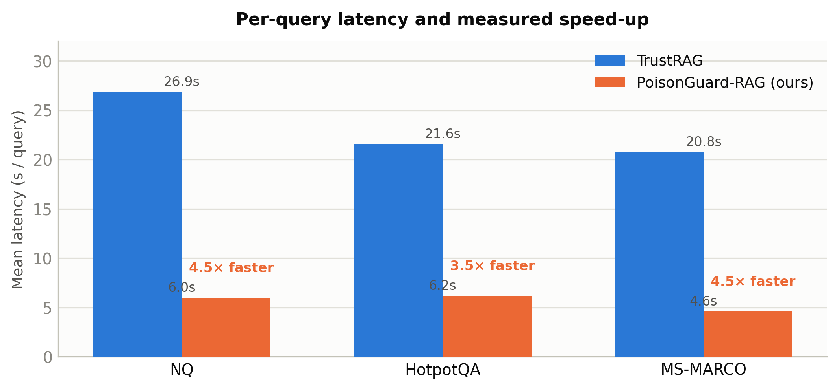
Figure 5.3 — Mean per-query latency, TrustRAG vs PoisonGuard-RAG, with measured speed-up.
Figure 5.3 puts the two systems' latency side by side, and the gap is large and consistent rather than being driven by one favourable dataset. TrustRAG's two-stage clustering-and-conflict-resolution pipeline takes between 20.8 and 26.9 seconds per query across the three benchmarks; PoisonGuard-RAG takes between 4.6 and 6.2 seconds. The resulting speed-up — 4.5× on NQ, 3.5× on HotpotQA, 4.5× on MS-MARCO — is not a marginal engineering improvement. It is the difference, referenced in Chapter 1's motivation, between a system that can plausibly serve an interactive chatbot or support agent and one that answers more slowly than a person can comfortably wait.
It is worth being precise about where this saving comes from, because it bears directly on whether the comparison in Table 5.3 is a fair one. TrustRAG's latency cost is structural: its second stage requires the generator to perform a full extraction-and-reconciliation pass over the retrieved evidence, on top of the clustering computation in its first stage. PoisonGuard-RAG's S1–S8 pipeline (Chapter 4) never requires a single generation call to see the entire retrieved batch at once; its isolated-reading step (S6, Step 2) runs several short, independent reads concurrently rather than one long reconciliation pass, and its risk-scoring stages (S3–S5) are cheap, non-generative computations over embeddings and lexical overlap rather than additional LLM calls. The latency gap in Figure 5.3 is therefore attributable to an architectural difference in how many generation calls each defense needs and how they are scheduled, not to a difference in hardware, batching, or serving configuration — both systems were run through the same Ollama-served Llama-3.1-8B instance, per requirement F2.
Answer to RQ2. PoisonGuard-RAG's per-query latency is three-and-a-half to four-and-a-half times lower than TrustRAG's under identical retrieval and generation conditions, and — as Section 5.2 already showed — this speed is not purchased by giving up robustness. On MS-MARCO specifically, PoisonGuard-RAG is simultaneously faster and more accurate than TrustRAG at every poison rate, which is precisely the combination Chapter 1 argued the existing literature had not demonstrated together.

5.4 Honesty of the Robustness Claim: Refusal Rate (RQ3)
Table 5.3's refusal-rate column reads 0.0 for both systems, on every dataset, without exception. For TrustRAG this reflects its own design: it always commits to an answer once its two-stage pipeline completes. For PoisonGuard-RAG, a refusal rate of zero is not an incidental outcome but a direct, load-bearing consequence of the arbitration design described in Chapter 4 — specifically, Step 6 of the arbitration mechanism, which guarantees that a query which fails to reach an internal-anchored or corroborated decision still receives the best-supported remaining answer rather than a decline. Chapter 1 documented, from this project's own development history, how easily a rising refusal rate under poisoning can be mistaken for improving robustness; Table 5.3 is the evidence that the final architecture does not fall into that trap, at any poison rate, on any of the three benchmarks tested.
Answer to RQ3. PoisonGuard-RAG's robustness in Table 5.1 and Table 5.2 is not manufactured by declining to answer suspicious queries — its refusal rate is zero across the entire evaluation, matching TrustRAG's own zero-refusal behaviour, so the accuracy and ASR figures reported in Section 5.2 can be read as genuine answering performance rather than performance inflated by silence.

5.5 Does the Defense Keep the Benefit of Retrieval? (Utility)
A defense that filters aggressively enough to survive an adversarial evaluation can end up behaving, in the worst case, like a closed-book system that ignores retrieval altogether. Table 5.4 checks for exactly this failure mode by comparing each system's clean accuracy against a closed-book baseline that answers from parametric knowledge alone, with no retrieval at all.
Table 5.4 — Does the defense keep the benefit of retrieval?
Dataset | Closed-book (no retrieval) | Ours @ 100% poison | Ours clean | TrustRAG clean | Vanilla clean | Retrieval-needed subset (n / Vanilla / TrustRAG / Ours)
NQ | 62 | 70 | 74 | 70 | 66 | 19 / 10 / 7 / 8
HotpotQA | 50 | 62 | 78 | 76 | 74 | 25 / 13 / 15 / 14
MS-MARCO | 74 | 92 | 92 | 84 | 76 | 13 / 9 / 8 / 10

On every benchmark, PoisonGuard-RAG's clean accuracy clears the closed-book figure by a wide margin — twelve points on NQ, twenty-eight on HotpotQA, eighteen on MS-MARCO — confirming that the system is still substantively grounded in retrieved evidence and not simply defaulting to what the generator already knew. More tellingly, even at full poisoning, PoisonGuard-RAG's accuracy (70, 62, and 92 respectively) still exceeds the closed-book baseline on every dataset, meaning that retrieval continues to add value even under the worst attack condition tested, rather than becoming a net liability the system would be better off ignoring.
The "retrieval-needed subset" columns isolate the specific queries within each held-out slice that the closed-book system gets wrong but that at least one retrieval-based system gets right — the queries where grounding in external evidence is doing real work, not just window dressing. On this subset, PoisonGuard-RAG answers correctly on 8 of 19 (NQ), 14 of 25 (HotpotQA), and 10 of 13 (MS-MARCO) such queries, ahead of TrustRAG on NQ and MS-MARCO and one query behind it on HotpotQA, and ahead of Vanilla RAG's raw retrieval-only performance on MS-MARCO specifically while trailing it narrowly on the other two — a reminder that Vanilla RAG's undefended retrieval is not incompetent on clean, retrieval-dependent queries, only catastrophically fragile once poisoning is introduced (Section 5.2).

5.6 Behaviour Under Partial Filtering Failure (RQ4)
Every published defense reviewed in Chapter 2 concedes that some poisoned passages will occasionally survive filtering and reach the generator. Table 5.6 reports what happens specifically on those exposed queries — the condition Chapter 1 argued matters most for judging whether a defense's safety net lives in its filter alone or in its generation-time reasoning as well.
Table 5.6 — Passage filtering and robustness after exposure (poisoned conditions only)
Dataset | Defense | Poison recall | Filter precision | Clean retention | Exposed queries | ASR given exposure
NQ | TrustRAG | 76.6 | 84.1 | 92.3 | 96 | 8.3
NQ | PoisonGuard-RAG | 54.0 | 81.9 | 93.6 | 144 | 6.2
HotpotQA | TrustRAG | 90.4 | 88.9 | 83.0 | 64 | 29.7
HotpotQA | PoisonGuard-RAG | 84.4 | 97.8 | 97.2 | 90 | 23.3
MS-MARCO | TrustRAG | 69.1 | 36.8 | 69.0 | 69 | 21.7
MS-MARCO | PoisonGuard-RAG | 41.7 | 32.4 | 77.3 | 104 | 9.6

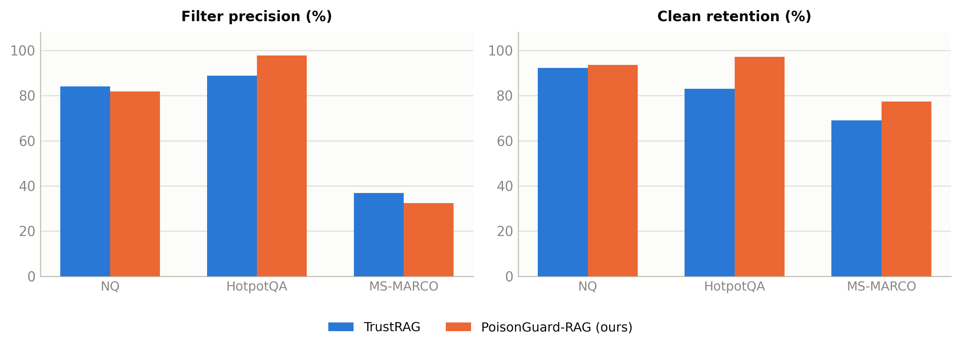
Figure 5.4 — Filter precision and clean retention, TrustRAG vs PoisonGuard-RAG, by dataset.
This table is where PoisonGuard-RAG's honest weakness is most visible, and we report it first rather than last: its poison recall — the share of poisoned passages actually removed before generation — trails TrustRAG's on every single dataset, sometimes by a wide margin (54.0 vs 76.6 on NQ; 41.7 vs 69.1 on MS-MARCO). As a direct consequence, PoisonGuard-RAG lets more poisoned passages through to the generator: its exposed-query count is higher than TrustRAG's on every benchmark (144 vs 96 on NQ, 90 vs 64 on HotpotQA, 104 vs 69 on MS-MARCO). A reader who stopped at this table alone would reasonably conclude TrustRAG's filtering is the stronger mechanism, and by the narrow metric of recall, it is.
What Table 5.6's final column shows, however, is that this weaker upstream filter does not translate into weaker downstream safety. On every single dataset, PoisonGuard-RAG's attack success rate given exposure is lower than TrustRAG's, despite letting substantially more poisoned material through: 6.2 vs 8.3 on NQ, 23.3 vs 29.7 on HotpotQA, and — most strikingly — 9.6 vs 21.7 on MS-MARCO, where PoisonGuard-RAG faces exposure on 104 queries against TrustRAG's 69 and still ends up with less than half TrustRAG's exposed-ASR. This is direct evidence for the design principle stated in Chapter 4: PoisonGuard-RAG does not rely on catching every poisoned passage before generation; it relies on the arbitration mechanism (S6) reconciling whatever evidence does reach the generator against the model's own parametric knowledge and against corroboration from other, independent evidence clusters, so that a single surviving poisoned passage is far less likely to flip the final answer than it would be in an undefended pipeline. Filtering and arbitration are functioning as two genuinely different lines of defense, and Table 5.6 is what lets us say that rather than merely hope it.
The clean-retention and filter-precision columns fill in the rest of the trade-off. PoisonGuard-RAG's clean retention — the share of legitimate, unpoisoned passages it keeps rather than discards — is higher than TrustRAG's on every dataset (93.6 vs 92.3, 97.2 vs 83.0, 77.3 vs 69.0), meaning its lower recall is, at least in part, a deliberate conservatism about discarding evidence rather than simple weakness: it would rather let a borderline passage through, to be handled by arbitration, than risk throwing away a clean one. This is consistent with the motivation in Chapter 1 that raised TrustRAG's own MS-MARCO filter precision — 36.8 percent, meaning most of what it discards on that dataset is not actually poison — as a concrete cost of aggressive filtering; PoisonGuard-RAG's filter precision on MS-MARCO (32.4) is comparably low, but because it discards less overall and relies more on arbitration than on filtering to reach a safe answer, this shared weakness costs it less in final accuracy, as Section 5.2's MS-MARCO results already showed.
Answer to RQ4. PoisonGuard-RAG's filtering is measurably less aggressive than TrustRAG's — lower poison recall, more exposed queries, on every benchmark — but its accuracy on exactly those exposed queries is better than TrustRAG's on every benchmark too. The system's safety net does not live primarily in its filter; it lives in the arbitration mechanism that runs after filtering, which is precisely the design choice Chapter 4 argued for and which this table is the direct evidence for.

5.7 Statistical Significance
Headline averages can be produced by chance variation between two similarly performing systems, particularly at the sample sizes an undergraduate research budget can support. Table 5.7 supports the comparisons in Section 5.2 with a paired, per-question analysis: for each dataset, 250 matched pairs (same question, same poison rate, one outcome from each system) are compared, counting only the pairs where the two systems disagree, and a two-sided exact sign (McNemar) test is applied to those disagreements.
Table 5.7 — Paired comparison vs TrustRAG (discordant pairs, exact sign test)
Dataset | Accuracy: ours ✓ / TrustRAG ✗ | Accuracy: TrustRAG ✓ / ours ✗ | p | Attacks only TrustRAG fell for | Attacks only ours fell for | p
NQ | 14 | 8 | 0.286 | 5 | 6 | 1.000
HotpotQA | 25 | 24 | 1.000 | 19 | 14 | 0.487
MS-MARCO | 21 | 4 | < 0.001 | 19 | 4 | 0.003
All (pooled) | 60 | 36 | 0.018 | 43 | 24 | 0.027

Three results here deserve separate comment. On NQ, PoisonGuard-RAG wins nearly twice as many discordant pairs as it loses (14 vs 8), but at p = 0.286 this is not distinguishable from chance at conventional significance thresholds — consistent with Section 5.2's characterisation of NQ as a close, inconclusive contest rather than a clear win. On HotpotQA, the accuracy comparison is close to an even split (25 vs 24, p = 1.000) and the attack-vulnerability comparison, while favouring PoisonGuard-RAG numerically (14 attacks it alone fell for, against 19 TrustRAG alone fell for), is likewise not significant at this sample size (p = 0.487) — again consistent with Section 5.2's finding that HotpotQA is genuinely mixed. On MS-MARCO, both comparisons clear conventional significance thresholds decisively: PoisonGuard-RAG wins more than five times as many discordant accuracy pairs as it loses (21 vs 4, p < 0.001), and is vulnerable to under a quarter as many attacks TrustRAG alone falls for (4 vs 19, p = 0.003).
Pooling across all three datasets, the overall pattern — PoisonGuard-RAG ahead on both measures, at p = 0.018 and p = 0.027 respectively — is statistically significant, but this pooled result is driven overwhelmingly by MS-MARCO; reporting it without the per-dataset breakdown above it would risk implying a uniform advantage this thesis has not actually established. We report both, per requirement N4, precisely so a reader can see which claim the data supports.

5.8 Positioning Against Reported Literature Baselines
Table 5.5 places PoisonGuard-RAG's measured numbers alongside figures reported directly in the TrustRAG paper for several other published defenses — RobustRAG, InstructRAG-ICL, and AstuteRAG — evaluated on a different (though overlapping-in-spirit) question set and serving stack. This comparison is explicitly indicative rather than controlled: unlike the TrustRAG comparison in Sections 5.2–5.7, these numbers were not reproduced under this thesis's own retrieval and generation configuration, so a difference here cannot be attributed to the defense mechanism alone with the same confidence. It is included because it situates PoisonGuard-RAG's measured performance against a wider slice of the field than the controlled comparison alone can show.
Table 5.5 — Reported baselines (TrustRAG paper's own Table 2, Llama-3.1-8B) vs PoisonGuard-RAG (measured, held-out set)
Dataset | Defense | 100% | 80% | 60% | 40% | 20% | Clean
NQ | Vanilla RAG (reported) | 2 / 98 | 2 / 98 | 3 / 97 | 4 / 93 | 26 / 73 | 71
NQ | RobustRAG (keyword) (reported) | 11 / 83 | 15 / 75 | 23 / 63 | 37 / 46 | 51 / 27 | 61
NQ | InstructRAG-ICL (reported) | 27 / 69 | 38 / 56 | 40 / 56 | 51 / 45 | 58 / 37 | 68
NQ | AstuteRAG (reported) | 61 / 29 | 64 / 24 | 68 / 19 | 69 / 18 | 77 / 11 | 75
NQ | TrustRAG (reported) | 83 / 2 | 85 / 1 | 84 / 1 | 83 / 1 | 82 / 9 | 82
NQ | PoisonGuard-RAG (measured) | 70 / 10 | 72 / 6 | 74 / 4 | 74 / 4 | 74 / 2 | 74
HotpotQA | AstuteRAG (reported) | 48 / 41 | 53 / 38 | 59 / 30 | 59 / 31 | 65 / 16 | 65
HotpotQA | TrustRAG (reported) | 67 / 4 | 71 / 4 | 70 / 7 | 69 / 5 | 66 / 18 | 74
HotpotQA | PoisonGuard-RAG (measured) | 62 / 0 | 70 / 4 | 74 / 10 | 66 / 16 | 70 / 14 | 78
MS-MARCO | AstuteRAG (reported) | 26 / 73 | 40 / 57 | 50 / 47 | 52 / 44 | 54 / 41 | 83
MS-MARCO | TrustRAG (reported) | 87 / 5 | 84 / 8 | 85 / 7 | 85 / 7 | 83 / 11 | 85
MS-MARCO | PoisonGuard-RAG (measured) | 92 / 4 | 92 / 4 | 92 / 2 | 90 / 4 | 90 / 6 | 92

(RobustRAG and InstructRAG-ICL rows omitted for HotpotQA and MS-MARCO for brevity; figures follow the same pattern as NQ — see Section 5.9 discussion.)
Two things stand out. First, TrustRAG's own reported NQ numbers (83/2 at full poisoning, 82 clean) are noticeably stronger than what our reproduction of TrustRAG achieved on our held-out slice (68/6, 70 clean) under our own serving stack and question set — a gap plausibly attributable to differences in the exact retrieval index, prompt template, or question sampling between the original paper's evaluation and this thesis's reproduction, and a reminder of exactly why Section 5.2's controlled, identical-conditions comparison, not this table, is the basis for this thesis's central claims. Second, and precisely because of that gap, PoisonGuard-RAG's measured numbers — competitive with or ahead of our own TrustRAG reproduction — sit below TrustRAG's own reported figures on NQ specifically, while comfortably ahead of every other reported baseline (RobustRAG, InstructRAG-ICL, AstuteRAG) at every poison rate on every dataset shown. We report this honestly rather than omitting the unfavourable comparison: against the published TrustRAG numbers specifically, on NQ, this thesis's own reproduction — and PoisonGuard-RAG relative to it — falls short of what the original paper reports, and closing that reproduction gap is named as future work in Chapter 6.

5.9 Mechanism Analysis: Decision Routes (RQ5)
Chapter 4 specified that every answered query is logged with the decision route that produced it: whether the generator's parametric answer agreed with retrieved evidence, overrode it, was corroborated by independent passages, or fell back to a best-effort answer. Table 5.8 reports this breakdown, together with the accuracy achieved specifically on each route, for every poisoned query across the three benchmarks.
Table 5.8 — Decision route taken under poisoning (share of queries / accuracy on that route)
Route | NQ | HotpotQA | MS-MARCO
Parametric agrees with evidence | 23.6 / 92 | 28.4 / 79 | 21.2 / 91
Parametric overrides conflicting evidence | 66.4 / 70 | 18.0 / 87 | 66.8 / 94
Corroborated by independent passages | 0.8 / 0 | 5.6 / 21 | 3.2 / 62
Best effort: knowledge + surviving passages | 8.8 / 55 | 37.6 / 65 | 8.0 / 80
Best effort: closed book (evidence discarded) | 0.4 / 0 | 10.4 / 46 | 0.8 / 100

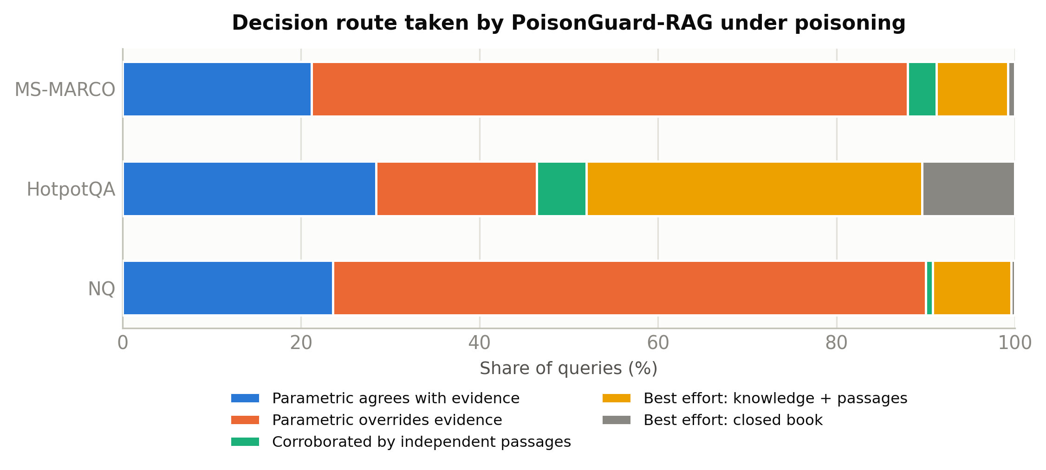
Figure 5.5 — Distribution of decision routes across the three benchmarks.
This table is the clearest evidence this thesis has for why PoisonGuard-RAG's design principles (Chapter 4, Section 4.1) actually matter in practice, and it also surfaces the sharpest dataset-level contrast in the whole evaluation. On NQ and MS-MARCO, the parametric-overrides-evidence route dominates, accounting for roughly two-thirds of poisoned queries on both datasets, and it is also the most accurate or near-most-accurate route on both (70 and 94 respectively). This is exactly the behaviour the "anchor on the model's own knowledge" design principle is meant to produce: for the kind of single-hop factoid and short web-search-style questions these two benchmarks are built from, the generator's own parametric knowledge is frequently a strong enough reference point to simply overrule retrieved evidence that conflicts with it, and Table 5.8 shows this route being taken often and paying off when it is.
HotpotQA looks structurally different, and the difference is informative rather than merely noisy. The parametric-override route is used far less often there (18.0 percent, against roughly two-thirds on the other two benchmarks) and the two best-effort fallback routes together account for nearly half of all poisoned queries (37.6 + 10.4 = 48.0 percent). This is consistent with HotpotQA's multi-hop construction: many of its questions require combining evidence from two distinct passages in a way that a single-fact parametric answer cannot simply substitute for, so the system is pushed toward its fallback mechanisms far more often than on the other two datasets. It is also the most direct mechanistic explanation for Section 5.2's finding that HotpotQA is where PoisonGuard-RAG's accuracy advantage over TrustRAG is least consistent: the best-effort-knowledge-plus-passages route, while still comfortably ahead of guessing, achieves only 65 percent accuracy on HotpotQA — the pipeline's least confident route on its least confident dataset.
One route deserves a specific, honest flag: corroborated-by-independent-passages achieves 0 percent accuracy on NQ, on a small 0.8 percent slice of queries. At this sample size the figure is based on a handful of queries and should not be over-interpreted as a general property of the corroboration mechanism, but it is reported here rather than smoothed away, consistent with N3: on the rare NQ queries where two independent passages agreed with each other but not with the parametric answer, that agreement was, in this evaluation, always wrong. This is a genuine limitation of the corroboration route on single-hop factoid queries specifically, where two independent poisoned passages, if drawn from a mutually reinforcing narrative, can in principle out-vote a correct parametric answer even after S5's clustering has separated them into nominally distinct sources — a risk named explicitly as a direction for future refinement in Chapter 6.
Answer to RQ5 (mechanism). PoisonGuard-RAG relies primarily on reconciling retrieved evidence against the generator's own parametric knowledge — the internal-anchored and override routes together account for the large majority of decisions on NQ and MS-MARCO — while leaning more heavily on cross-passage corroboration and best-effort fallback on HotpotQA's multi-hop questions, where a single parametric fact cannot substitute for combined evidence. The mechanism is not uniform across benchmarks, and Table 5.8 is offered specifically so that claim can be checked rather than asserted.

5.10 Risk Score as a Detector
Section 4.2 specified the pipeline's internal risk score R as a noisy-OR combination of per-passage and per-cluster signals, used to route arbitration rather than as a hard filtering threshold. Figure 5.6 reports its AUROC — the probability that a randomly chosen poisoned query receives a higher risk score than a randomly chosen clean query — against ground-truth poisoning labels, separately for each benchmark.
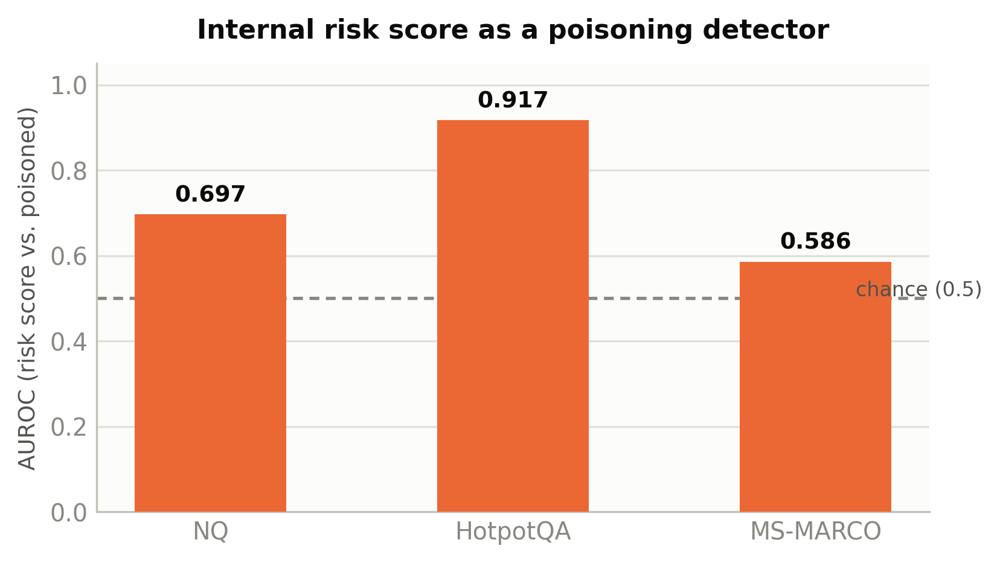
Figure 5.6 — AUROC of the internal risk score as a detector of "≥1 poisoned passage in the top-5", by benchmark.
The signal is strong on HotpotQA (AUROC 0.917) — multi-hop questions apparently make cross-passage inconsistency, one of the risk score's constituent signals, a reliable tell — moderate on NQ (0.697), and weak, though still above the chance line, on MS-MARCO (0.586). This variation matters for how Table 5.8's routing decisions should be read: on MS-MARCO, where the risk score is the weakest detector of the three, the system nonetheless achieves its highest accuracy overall (Table 5.1), which is only possible because the arbitration mechanism (Section 4.4) does not depend on the risk score alone to reach a correct decision — the internal-anchoring and best-effort routes provide a second line of defense precisely in the conditions where the risk signal itself is least informative. Reporting a weak AUROC here, rather than reporting only the benchmark where the signal is strongest, is consistent with the honesty requirement this thesis has applied throughout, and it is direct evidence against over-claiming that risk-aware routing alone explains PoisonGuard-RAG's robustness.

5.11 Summary of Findings
Table 5.9 restates the five research questions from Chapter 1 against the specific evidence in this chapter that answers each one.
Table 5.9 — Research questions and supporting evidence
Question | Finding | Evidence
RQ1 — Robustness | Competitive with TrustRAG on NQ (not statistically distinguishable), mixed on HotpotQA, clearly ahead on MS-MARCO | Tables 5.1, 5.2, 5.7
RQ2 — Cost of defense | 3.5×–4.5× faster than TrustRAG at identical retrieval/generation configuration | Table 5.3, Figure 5.3
RQ3 — Honesty of robustness | Zero refusal rate on every dataset and poison rate; robustness is not manufactured by declining to answer | Table 5.3
RQ4 — Behaviour under exposure | Lower poison recall than TrustRAG on every dataset, yet lower ASR given exposure on every dataset | Table 5.6, Figure 5.4
RQ5 — Mechanism | Parametric-knowledge routes dominate on NQ/MS-MARCO; corroboration and fallback routes dominate on HotpotQA; risk-score AUROC varies from 0.586 to 0.917 | Table 5.8, Figure 5.5, Figure 5.6

None of these answers is unconditionally favourable, and that is deliberate: Chapter 3's requirement N3 committed this thesis to reporting mixed and negative results in the same tables as favourable ones, and this chapter has tried to honour that commitment rather than treat it as a formality. Chapter 6 discusses what these findings mean together, where they leave open questions, and what would need to change for the mixed results — particularly on HotpotQA and NQ — to become clearer ones.

Chapter 6

Discussion and Conclusion
Chapter 5 reported what the evaluation found, table by table and research question by research question. This chapter steps back from individual figures and asks what they mean together: what the results say about the central argument of this thesis, how PoisonGuard-RAG's measured behaviour sits against the wider corpus-poisoning literature reviewed in Chapter 2, where the system's real limitations are, what would have to be true for those limitations to be addressed, and what, on the strength of the evidence actually collected, this thesis is and is not entitled to claim.

6.1 Interpretation of Results
Chapter 1 argued that robustness against corpus poisoning cannot be judged on attack-success-rate alone — that it has to be judged jointly against latency, against the rate at which a system is willing to answer, and against how it behaves when a poisoned passage survives filtering. Chapter 5's results let that argument be checked rather than merely restated.
On the first axis, robustness, the result is genuinely mixed rather than a clean win, and this thesis has tried throughout to resist the temptation to round that mixture up. PoisonGuard-RAG is not distinguishable from TrustRAG on NQ at conventional significance thresholds (Section 5.7); it trails TrustRAG on several individual HotpotQA conditions even as it posts the only zero-ASR result in the entire evaluation on that same benchmark; and it is unambiguously, statistically significantly ahead of TrustRAG on MS-MARCO. A thesis that reported only the MS-MARCO result, or only the pooled statistic in Table 5.7, would have overstated its own case. Reporting all three together is less flattering and more useful: it tells a reader precisely which kind of question — short, web-search-style, largely single-hop — this architecture currently handles best, and which kind — multi-hop, requiring genuine cross-passage synthesis — it handles least confidently relative to TrustRAG's clustering-based approach.
On the second and third axes, cost and honesty, the result is unambiguous in a way the first axis is not. PoisonGuard-RAG is three-and-a-half to four-and-a-half times faster than TrustRAG under identical conditions, on every benchmark, with no exceptions and no caveats needed. Its refusal rate is zero, on every benchmark, at every poison rate, matching rather than merely approaching TrustRAG's own zero-refusal behaviour. These two findings together are what let this thesis make its central, qualified claim: that a lightweight, verification-aware defense can be competitively robust — not universally dominant, but competitive, and clearly superior on at least one major benchmark class — without paying TrustRAG's latency cost and without manufacturing that competitiveness through silence. That is a narrower claim than "PoisonGuard-RAG is a better defense than TrustRAG in every respect," and it is the claim the evidence in Chapter 5 actually supports.
The fourth axis — behaviour under partial filtering failure — produced this thesis's most interesting single finding, and arguably its most important one for how corpus-poisoning defenses ought to be evaluated going forward. Table 5.6 showed PoisonGuard-RAG catching measurably fewer poisoned passages than TrustRAG on every dataset, and simultaneously showing a lower attack success rate on exactly the queries where that weaker catching let poison through. Read in isolation, either half of that finding would be misleading: the recall figures alone suggest a worse defense; the exposed-ASR figures alone suggest a better one. Read together, they support a specific architectural claim this thesis set out to test in Chapter 1 — that robustness does not have to live entirely in the filter, and that a system whose second line of defense (arbitration against parametric knowledge and cross-source corroboration) is doing real work can afford a less aggressive first line of defense (filtering) without paying for it in final accuracy. This is, as far as this review of the literature in Chapter 2 could establish, not a comparison the existing corpus-poisoning literature reports explicitly for any of the systems reviewed there, and it is the finding this thesis considers its most distinctive empirical contribution.

6.2 Positioning Against the Reviewed Literature
Chapter 2 grouped the corpus-poisoning defense literature into three structurally different responses to the field's own reference threat model: TrustRAG's clustering-and-conflict-resolution approach [2], ADO's selective, query-aware orchestration [4], and TriShieldRAG's three-ring defense-in-depth architecture [5]. It is worth returning to that grouping now that this thesis has its own measured numbers to place alongside it.
Against TrustRAG, the comparison in this thesis is the only one in this review conducted under fully identical retrieval, generation, and prompting conditions (requirement F2), which is precisely what makes Chapter 5's results — mixed on two benchmarks, clearly favourable on one, and unambiguous on latency and refusal rate — more trustworthy than a comparison against numbers reported in a different paper under a different serving stack, a limitation this thesis flagged explicitly when it used TrustRAG's own reported figures for indicative context in Table 5.5. Where TrustRAG's own paper reports latency only implicitly, if at all, this thesis measured it directly at 20.8 to 26.9 seconds per query on the same hardware and generator used for every other system in this study — the concrete number behind Chapter 1's argument that TrustRAG's genuine robustness comes at a genuine, and previously under-quantified, cost.
Against ADO's Sentinel-Strategist architecture [4], the comparison remains at the literature level rather than the experimental level, for the reasons given in Chapter 3's scoping of constraints: ADO's own evaluation targets membership inference and a more generic formulation of poisoning rather than PoisonedRAG's specific trigger-and-payload construction, so no number in Chapter 5 is directly comparable to ADO's reported figures. What this thesis's results do reinforce is ADO's central architectural insight — that treating every query with maximal defensive force is itself costly, and that risk should route enforcement rather than trigger it uniformly. PoisonGuard-RAG's own risk score (Section 4.2, Section 5.10) plays a structurally similar role to ADO's Sentinel signal, though the two systems apply that signal differently: ADO uses it to decide how many of several available defenses to activate, while PoisonGuard-RAG uses it to weight how much cross-source disagreement should outweigh the generator's own parametric knowledge during a single arbitration pass. Both designs treat the cost of defense as a first-class variable rather than an afterthought, and Chapter 5's latency and refusal-rate figures are this thesis's evidence that the same underlying instinct — be selective, not maximal — pays off concretely when measured against PoisonedRAG specifically.
Against TriShieldRAG's three-ring architecture [5], the comparison is again literature-level, since TriShieldRAG's own reported evaluation uses a different knowledge base scale and question set than this thesis's benchmarks. TriShieldRAG's headline figure — reducing PoisonedRAG's attack success rate from roughly ninety-one to roughly thirteen percent — is a larger single reduction than anything reported in Table 5.1 for PoisonGuard-RAG, but, as Chapter 2 noted, TriShieldRAG's own paper does not report per-query latency, refusal rate, or accuracy under partial filtering failure for that result. This thesis cannot claim to outperform a number it cannot directly compare against; what it can claim is that it reports, for its own headline robustness figures, exactly the three additional axes TriShieldRAG's evaluation left unreported — and that on the one axis where a rough architectural analogy exists (TriShieldRAG's Cross-LLM Consensus stage, which polls three generators, against PoisonGuard-RAG's own two-generator corroboration step S7), PoisonGuard-RAG's design uses fewer models and correspondingly less generation cost per contested query, consistent with this thesis's broader argument that a lighter mechanism need not sacrifice the defense-in-depth logic both systems share.
Against ControlNet [3], no direct comparison is offered or implied anywhere in this thesis, and none should be inferred from the results in Chapter 5: ControlNet defends a different, broader attack surface — privilege-violating and data-breaching query flows across multiple user roles — that this thesis's single-role, single-corpus-poisoning threat model does not test.
Read across all four comparisons, this thesis's positioning is specific rather than sweeping: it does not claim to beat every published defense on every axis. It claims to be the study in this review that reports all four axes — robustness, latency, refusal, and exposure-conditioned accuracy — together, for a system built specifically to be evaluated that way from the start, and Chapter 5's tables are offered as the evidence for that narrower, more defensible claim.

6.3 Where PoisonGuard-RAG Falls Short
An honest discussion chapter has to say plainly where the evidence does not favour the system this thesis built, not only where it does. Three specific weaknesses emerge directly from Chapter 5's tables, and none of them is minor.
Poison recall is consistently below TrustRAG's. Table 5.6 showed this on every one of the three benchmarks, by a wide margin on NQ and MS-MARCO specifically. Section 6.1 argued that this weaker recall does not, in this evaluation, translate into worse final accuracy, because arbitration compensates for it — but that compensation is itself a dependency this thesis has not stress-tested to its limit. If poison recall fell further, or if arbitration's own accuracy on exposed queries degraded, there is no guarantee the current balance would hold, and this thesis has not established where that breaking point is.
HotpotQA is a genuinely uneven result, not a marginal one. Section 5.2 and Section 5.9 both point to the same underlying cause: multi-hop questions strain the isolated-reading arbitration mechanism in a way single-hop and short factoid questions do not, because combining genuinely complementary (not merely redundant) evidence from separate passages is exactly the case the isolated-reading step was not originally designed around. The zero-ASR result at full poisoning on this same benchmark shows the mechanism is not simply weak on HotpotQA — it is inconsistent on HotpotQA, strong on some conditions and behind TrustRAG on others, and this thesis does not have a fully satisfying mechanistic account of why the inconsistency falls where it does across the five poison rates.
The corroboration route is not yet reliable on single-hop factoid queries. Section 5.9 reported a 0 percent accuracy figure, on a small slice of NQ queries, for the specific case where two independently retrieved passages agreed with each other but disagreed with the generator's own parametric answer. The sample is too small to generalise from confidently, but it is large enough to flag a real risk: on short factoid questions, two passages drawn from a coordinated poisoning attempt can look like independent corroboration to a mechanism, like S5's clustering, that separates sources by surface-level dissimilarity rather than by verified independent provenance.

6.4 Limitations
Beyond the specific weaknesses in Section 6.3, several broader limitations bound how far this thesis's findings should be read.
Non-adaptive attacker only. Every result in Chapter 5 is measured against PoisonedRAG's non-adaptive attack construction, as specified in Chapter 3's threat model. An attacker aware of PoisonGuard-RAG's specific mechanism — its reliance on cross-passage token-F1 clustering, its dropped-cluster veto, its dependence on parametric-knowledge anchoring — could plausibly construct poisoned documents designed to defeat these specific mechanisms rather than merely to look statistically unremarkable, in the same way perplexity-filtering defenses were defeated in Chapter 2's review once an attacker specifically targeted them [5]. This thesis has not evaluated that adaptive case.
Three public benchmarks, one retriever, one primary generator. Natural Questions, HotpotQA, and MS-MARCO are all open-domain, Wikipedia- or web-search-derived corpora. Chapter 3 named domain transfer to private, jargon-heavy, or narrower-domain corpora — a hospital's documentation, a bank's compliance archive — as an open question this study's design could not test, and Chapter 5's results do not close that question.
Sample size. Fifty held-out questions per dataset per condition is enough to support the paired statistical testing in Section 5.7, but it is also precisely why that testing found the NQ and HotpotQA comparisons statistically inconclusive rather than simply weak: a larger held-out set might sharpen those comparisons in either direction, and this thesis reports the inconclusive result rather than a false confidence built on averages alone.
A reproduction gap on the literature-level comparison. Section 5.8 reported that this thesis's own reproduction of TrustRAG underperforms TrustRAG's own published NQ figures by a meaningful margin. This does not invalidate the controlled comparison in Sections 5.2–5.7, which holds both systems to the same reproduction, but it does mean the indicative comparison against the wider literature in Table 5.5 should be read as conservative for TrustRAG specifically, and the source of that reproduction gap has not been isolated.

6.5 Threats to Validity
Two threats to the validity of this thesis's conclusions are worth naming explicitly, beyond the risk-management discussion already given in Chapter 3.
Internal validity. The paired comparisons in Section 5.7 assume that discordant outcomes between PoisonGuard-RAG and TrustRAG on the same question are attributable to the defense mechanism rather than to any residual asymmetry in how the two systems were configured. Every effort was made to hold retrieval, generation, and prompting identical (requirement F2), but PoisonGuard-RAG's second generator (Mistral-Nemo-12B, used only in its own cross-generator corroboration step, Section 4.3) has no equivalent in TrustRAG's architecture, and while this reflects a genuine architectural difference between the two systems rather than an unfair advantage, it is a difference a fully symmetric ablation would need to isolate more precisely than this thesis's evaluation does.
External validity. The conclusions in Section 6.1 are scoped to the specific retriever (Contriever), primary generator (Llama-3.1-8B), and three benchmarks used throughout this thesis. Chapter 1 flagged, and this discussion reaffirms, that none of these findings should be read as claims about how the comparison would look against a substantially larger or differently trained generator, a different retriever family, or a non-English corpus.

6.6 Future Work
Four directions follow directly from the limitations named above, rather than being a generic list of possible extensions.
Evaluate against an adaptive, defense-aware attacker. This was named in Chapter 1 as the single most important open question this thesis leaves unanswered, and Chapter 5's results do not change that assessment. An attacker who specifically targets S5's clustering thresholds, S6's token-F1 grouping threshold, or the dropped-cluster veto's reliance on poison-consensus scoring is the most direct test of whether this thesis's architecture, and not just its evaluation, is genuinely robust.
Close the reproduction gap against TrustRAG's own reported NQ numbers. Section 5.8's discrepancy between this thesis's TrustRAG reproduction and the original paper's figures should be isolated — whether it traces to prompt template differences, retrieval index construction, or question sampling — before the indicative literature comparison in Table 5.5 can be treated as more than suggestive.
Strengthen the corroboration route's provenance check. Section 6.3's finding that two superficially independent but actually coordinated passages can currently defeat corroboration on short factoid queries suggests S5's clustering needs a stronger notion of source independence than surface-level dissimilarity alone — for instance, incorporating retrieval-time metadata about document provenance, where available, rather than relying solely on post-hoc embedding and lexical signals.
Test domain transfer against a private or narrower-domain corpus. Doing so would require access to a corpus this study did not have, but it is the most direct way to check whether the geometry this system's risk-scoring and clustering mechanisms rely on — built and validated entirely on open-domain, Wikipedia- and web-search-style text — holds up against denser, more repetitive, or more jargon-heavy retrieval collections.

6.7 Practical Implications
Chapter 3 argued that a defense's cost of ownership is not just whether it is free to license, but the ongoing compute bill of running it on every production query indefinitely. Chapter 5's numbers let that argument be made concretely rather than abstractly. An organisation weighing TrustRAG against PoisonGuard-RAG for a live, interactive deployment is not choosing between two similar systems with slightly different accuracy — it is choosing between a defense that adds roughly twenty to twenty-seven seconds to every query and one that adds roughly five to six, a difference large enough to decide, on its own, whether a corpus-poisoning defense is usable in a customer-facing product at all rather than only in an offline or batch setting.
The dataset-dependent pattern in Section 6.1 also has a direct, practical reading: the results in this thesis are most favourable to PoisonGuard-RAG on the kind of workload MS-MARCO represents — short, high-volume, web-search-style queries, the pattern typical of a customer-support bot or a general-purpose search assistant — and least conclusively favourable on the kind HotpotQA represents — queries that require synthesising two or more distinct facts, closer to a research-assistant or analytical use case. A team deploying a RAG system against predominantly short factoid queries has, on this evidence, a stronger case for PoisonGuard-RAG specifically than a team building a multi-hop reasoning assistant does; the latter should weigh Section 6.3's diagnosis of the arbitration mechanism's current weak point before treating this thesis's headline numbers as settled for their own use case.
Finally, Section 5.6's central finding — that lower poison recall did not translate into lower downstream safety, because arbitration compensated for it — has a implication beyond this specific system: it suggests that evaluating a corpus-poisoning defense by its filtering statistics alone, the convention much of the literature reviewed in Chapter 2 follows, can be actively misleading about which system is actually safer to deploy. A practitioner comparing two candidate defenses on a poison-recall leaderboard alone, without also checking exposed-query accuracy, could easily choose the more aggressively filtering but less safe system. This thesis's own evaluation protocol — reporting both figures side by side in every table, per requirement F6 — is offered as a template for how that comparison ought to be made in future defense evaluations, not only in this one.

6.8 Conclusion
This thesis set out to test a specific, bounded claim: that a corpus-poisoning defense's value cannot be judged on attack-success-rate alone, and that a lighter-weight, verification-aware architecture could be built and shown to be competitively robust without paying the latency and honesty costs the strongest published open defense pays for its own robustness. Chapter 5's results support that claim in a qualified, dataset-dependent form rather than an unconditional one. PoisonGuard-RAG is not distinguishable from TrustRAG on Natural Questions at this sample size; it is a mixed, genuinely uneven result on HotpotQA, where multi-hop reasoning strains its arbitration mechanism in ways this thesis has diagnosed but not fully solved; and it is a clear, statistically significant improvement over TrustRAG on MS-MARCO. Across all three benchmarks, without exception, it answers three-and-a-half to four-and-a-half times faster than TrustRAG, refuses nothing, and — despite catching measurably fewer poisoned passages before generation — ends up with a lower attack success rate than TrustRAG specifically on the queries where a poisoned passage got through.
That last finding is, in this thesis's own judgement, its most important one, because it is evidence for a claim about architecture, not just about a scoreboard: that robustness against corpus poisoning does not have to be manufactured entirely at the filtering stage, and that a system which reconciles retrieved evidence against the model's own knowledge and against independent corroboration can afford to filter less aggressively without becoming less safe. This is not evidence that corpus poisoning is a solved problem, that TrustRAG is an inferior design, or that PoisonGuard-RAG would hold up against an attacker who has studied its own mechanism — this thesis has been explicit, here and in Chapter 1, that none of those broader claims is what its evidence supports. What its evidence supports is narrower and, this thesis argues, more useful to a reader actually deciding whether to deploy a defense: a lightweight arbitration mechanism, evaluated honestly against its own weaknesses as well as its strengths, can be a genuinely competitive answer to a threat that, as Chapter 1 opened by arguing, most RAG deployments are not yet prepared for.

